|  |  |  |  |  |  |
| --- | --- | --- | --- | --- | --- |
| Course Title: | Data Warehousing and data Mining | Course Code: | CSC496 | Credit Hours: | 3(3,1) |
| Student Name: | **Asad Ali** | Reg. No. | **SP21-BCS-007** | | |
| Important Instructions / Guidelines:   * Attempt all questions. | | | | | |
| Submission Date: 10-06-2023 | | | | | |

**Instructions:**

* Take Data set of your choice and perform tasks using WEKA
* Create association rules and show strong rules.
* Apply 2 to 3 Classification algorithms and show results of best classifier.
* Apply Clustering Algorithms and show results.
* Take screenshots of your work and create a word file and submit it.

**Solution:**

* **Data:**

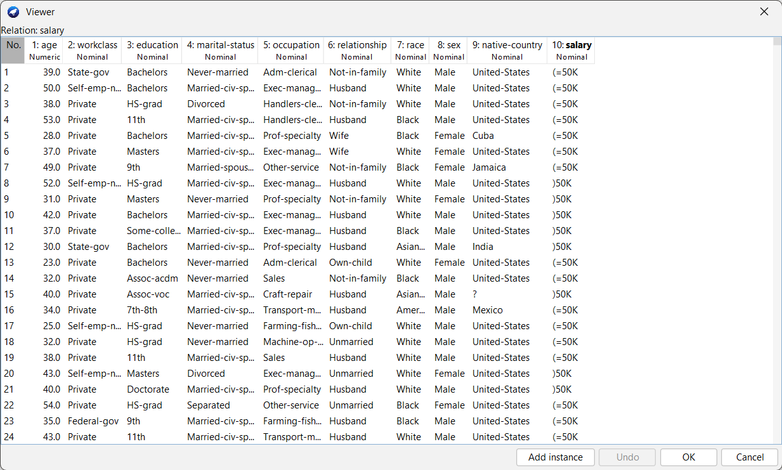

* **Classifications:**

* **Clustering:**

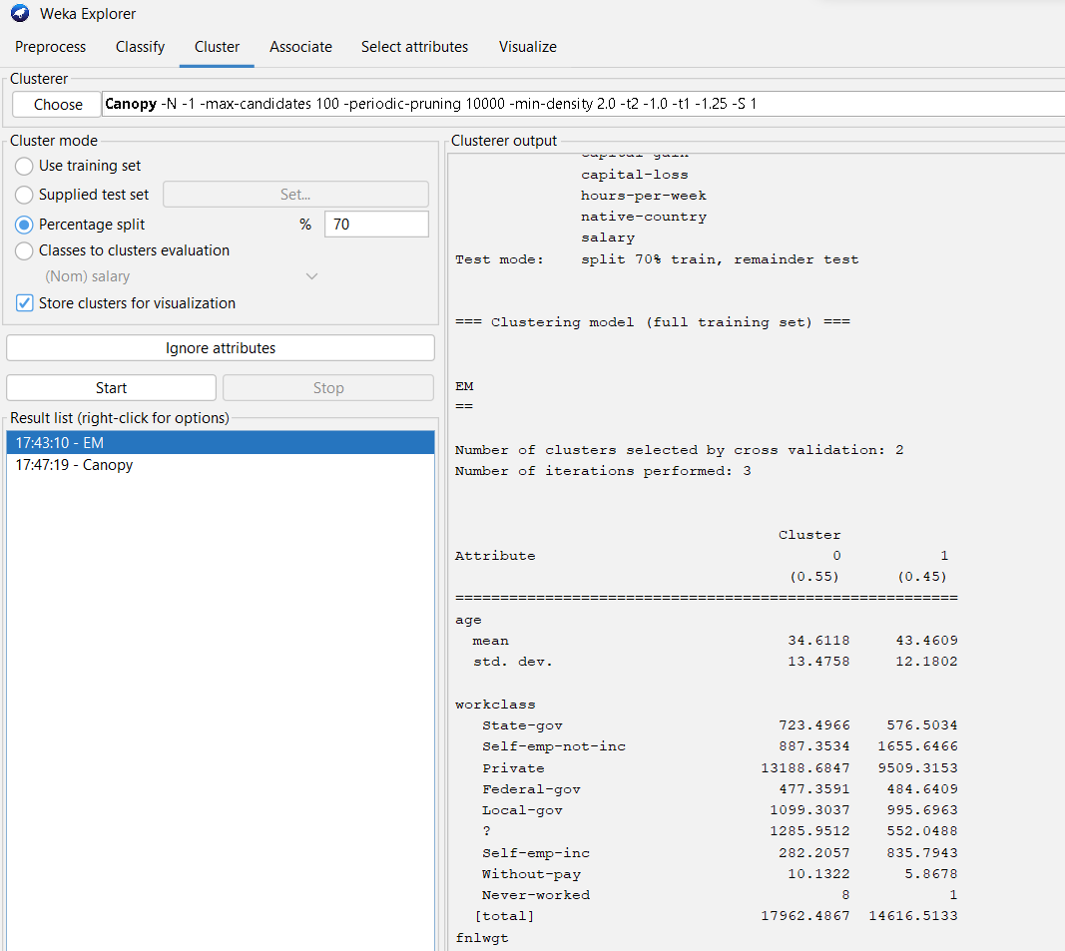

*     **Association Rules:**

